

Possession - User Stories & Wireframes

Contents
User Stories- Possession Process 3
1. User Story- Request Possession Order 3
1.1 Mock-ups 5
2. User Story- Approve/Reject Possession Order Request 7
2.1 Mock-ups 8
3. User Story- Change in Area 11
3.1 Mock-ups 12
4. User Story- View Request- Department User 13
4.1 Mock-ups 15
5. User Story- View Request- Approver 19
5.1 Mock-ups 20
6. User Story- Resubmit request for possession order 21
6.1 Mock-ups 22
7. User Story- Cancel possession order request 23
7.1 Mock-ups 24
8. User Story- View Comment 25
8.1 Mock-ups 26
9. User Story- Generate Possession Certificate 27
9.1 Mock-ups 28
10. User Story- Generate Payment challan- One Time Excess Area Charge 29
10.1 Mock-ups 30
11. User Story- Generate Revised payment schedule 31
11.1 Mock-ups 32
12. User Story- SMS/Email Notifications to allottee 33

Changes

S NO | MODULE | DESCRIPTION | Date
1 | All | Updated Mockups | 27/06/20116
2 | All | Acceptance criteria updated | 27/06/20116

User Stories- Possession Process

User Story- Request Possession Order

Sprint | 5
User Story ID | 001
User Story Title | Request Possession Order
Actors | Department user
Story | As a department user, I want to request for possession order of a property from engineering department, so that I can generate possession certificate.
Pre Conditions | - User should have required access rights.
Business Criteria | - There would be only one request per property.  - User would be able to add possession order for his department only.  - Unique Request no. would be generated for each possession order request.  - Once, the request is submitted a notification would be sent to approver for the same.  - Auto notifications will be sent to approver with an interval of 3 days, if a request is in progress for approval for more than 3 days.  - An Email/SMS notification would be sent to allottee along with the request no.  - If a request is submitted to an approver but not actioned its status would be ‘Pending’. Approved and rejected requests would have ‘approved’ and ‘rejected’ status respectively.  - If the request is cancelled by the department user, its status would be ‘cancelled’.  - If Approver changes area of the property then, Area change column in grid would contain ‘Yes’, else it would contain ‘No’.
Acceptance Criteria | - User would click on ‘Request Possession Order’ option under Manage possession menu and get a form which contain following fields:  - RID: drop down  - Based on this selection the following information would be displayed:  - Property No  - Applicant Name  - Gender  - Father/Husband Name  - Mobile Number  - Address  - Scheme Name  - Department  - Property type  - Floor (in case of Flats)  - Area  - Possession due date  - User would enter the possession due date.  - Once, user validates the information he would submit request for possession order to engineering department by clicking on ‘Submit Request’ button. User would get a popup to select approver name, user would select desired name and click on ‘Submit’ button.  - Alternatively, user would click on ‘back’ button to return to manage possession menu without making any changes.  - After successful submission of request it would be displayed in a grid on manage possession page with following columns:  - Request No  - RID  - Property No  - Request date  - Possession date (for approved entries)  - Area Change (yes, no)  - Status (pending, cancelled, approved, Rejected)
Field level Validation

Mock-ups

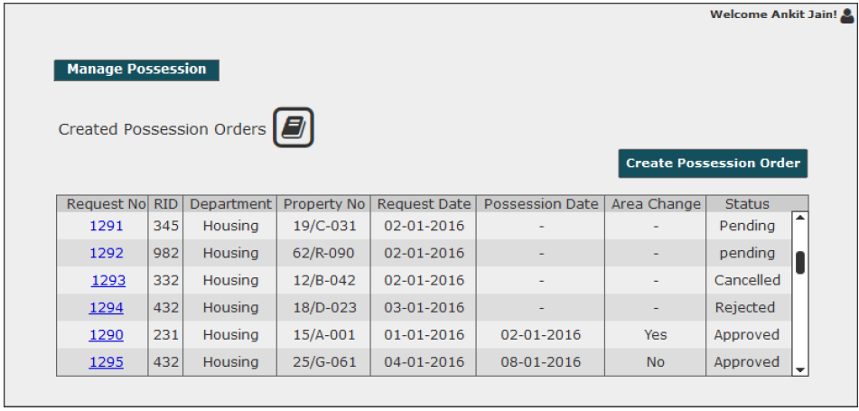
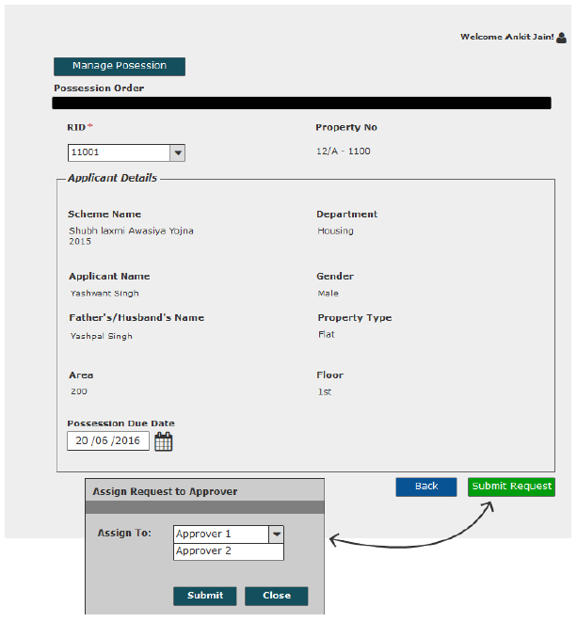

User Story- Action Possession Order

Sprint | 5
User Story ID | 002
User Story Title | Action Possession Order
Actors | Approver
Story | As an approver, I want to action possession order request of a property so that I can issue possession.
Pre Conditions | - User should have required access rights.
Business Criteria | - Once a request is actioned a notification would be send to initiator of the request.  - It is mandatory to provide a comment if possession not issued.  - Approver can re-issue possession.  - It is mandatory to provide a comment on re-issuing possession.  - If possession is given then status would be ‘Approved’ if no possession is given then status would be ‘Rejected’.  - If the request is cancelled by the department user, its status would be ‘cancelled’. Approver would not get any options to action for these requests.  - Change in area of the property would update in the database only when possession is given.  - Property cost would be re calculated in case of decrease in area.  - In case of increase in Area, one time excess charge would be calculated by the system as per the below formula:  Excess area amount calculation = Excess Area * Allotment Rate (Units in per Sq. mtr)  - In case of decrease in area, system would recreate the payment schedule based on new property cost.  - If Approver changes area of the property then, Area change column in grid would contain ‘Yes’, else it would contain ‘No’.
Acceptance Criteria | - User would click on ‘Possession Orders’ option under ‘Manage Request’ menu and get a grid which contain possession order requests information with following columns:  - Request No  - RID  - Department  - Property No  - Request date  - Possession date (for approved entries)  - Status (pending, approved, rejected, cancelled)  - Area Change (yes, no)  - User would click on the request no. to action request and based on this selection the following information would be displayed:  - RID  - Property No  - Scheme Name  - Department  - Applicant Name  - Gender  - Father/Husband Name  - Property type  - Area  - Floor (in case of housing department)  - Possession Due Date  - User would select Possession details.  - If user selects possession as ‘No’ from the radio button then no fields would be visible.  - If user selects possession as ‘Yes’ from the radio button then following fields would be visible:  - Possession date: date, mandatory (to be filled by approver)  - North: textbox, mandatory  - South: textbox, mandatory  - East: textbox, mandatory  - West: textbox, mandatory  - Change in area: radio button, mandatory ( Yes/No)  - If user finds that the Area of a property has been changed then, he would select ‘Yes’ option and following field would be visible:  - Change type: dropdown ( Decrease in Area, Increase in area)  - Changed Area (Sqmt): Textbox  - In case of no change in area user would select ‘No’ option and no fields would be visible.  - User would clicks on submit button, in case of no possession user has to provide a comment while in case of possession user has the option to provide comment.  - Once request is submitted, flow would return to the manage request screen.
Field level Validation | - Comment: Text, maximum 500 characters, mandatory in case of no possession.  - Changed Area: Decimal (13,2).  - North: Text, maximum 100 characters.  - South: Text, maximum 100 characters.  - East: Text, maximum 100 characters.  - West: Text, maximum 100 characters.

2.1 Mock-ups

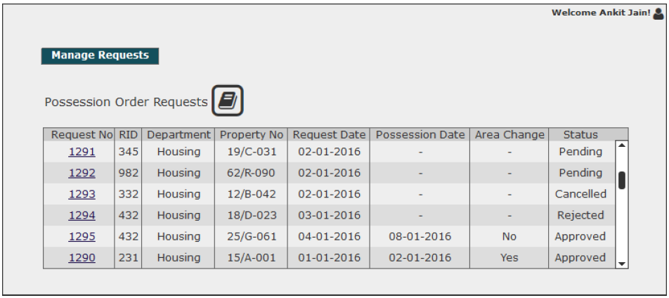
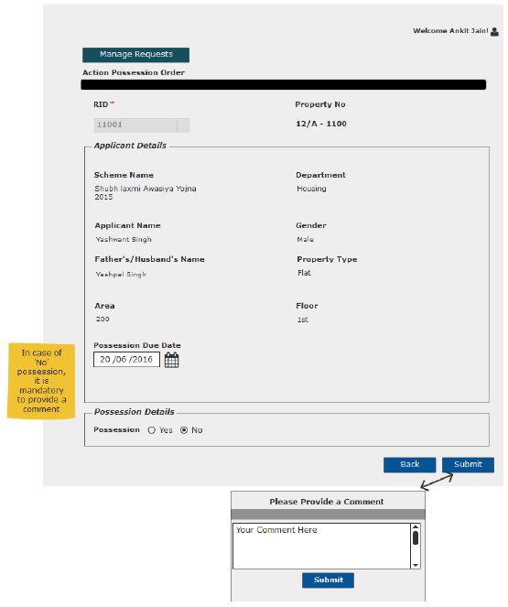
No Possession Case

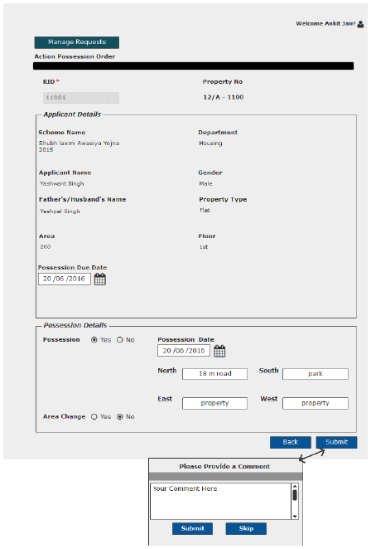
Possession with no area change
Possession with increase in area

Possession with decrease in area

User Story- View Request- Department User

Sprint | 5
User Story ID | 004
User Story Title | View Request
Actors | Department User
Story | As a department user, I want to view submitted possession order request of a property.
Pre Conditions | - User should have required access rights.
Business Criteria | - If request is submitted but not actioned by the approver then user would get ‘Cancel Request’ option only.  - Requestor has the option to request again for possession, in case possession not given for a request. Requestor would get the option of ‘Resubmit Request’ and ‘View Comment’ for these request.  - For cancelled requests user would get the option to ‘resubmit Request’.  - If possession is given requestor would get following options:  - Generate Possession Letter  - (Revised) Payment schedule (in case of decrease in area)  - (One time excess) payment challan ( in case of increase in area)  - View Comment  - Back button
Acceptance Criteria | - User would click on a particular request from the grid under manage Possession menu  - User would get a screen which would display the following information:  - RID  - Property No  - Scheme Name  - Department  - Applicant Name  - Father/Husband Name  - Property type  - Area  - Floor (in case of flats)  - Possession Due Date  - Possession details: In case of possession  - Possession Date: disabled ( for approved requests)  - Location: disabled ( North, South, East, West)  - Area Change: disabled (in case of change in area)  - In case of increase in area:  - Change Type: disabled label  - Changed Area: disabled label  - One time excess charge: Textbox  - In case of decrease in area:  - Decrease in Area: disabled label  - Changed Area: disabled label  - Revised Payment Schedule: button  - Along with this information, user would get different options based on the scenario( see Business Rules)  - If user clicks on ‘Back’ button, flow would return to Manage Possession screen
Field level Validation

Mock-ups
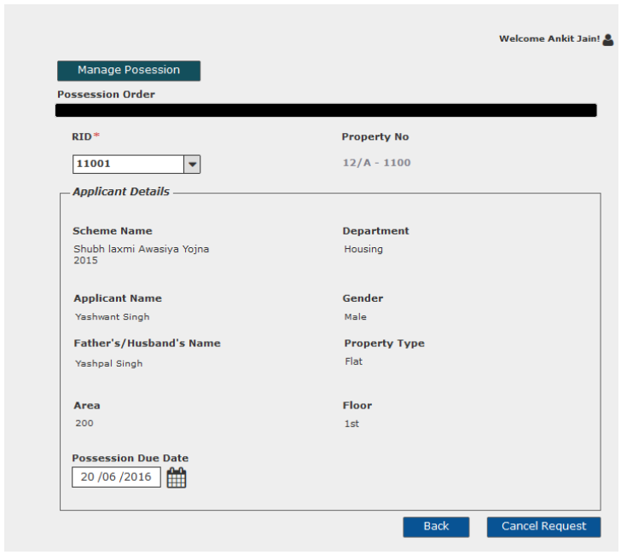
Canceled request
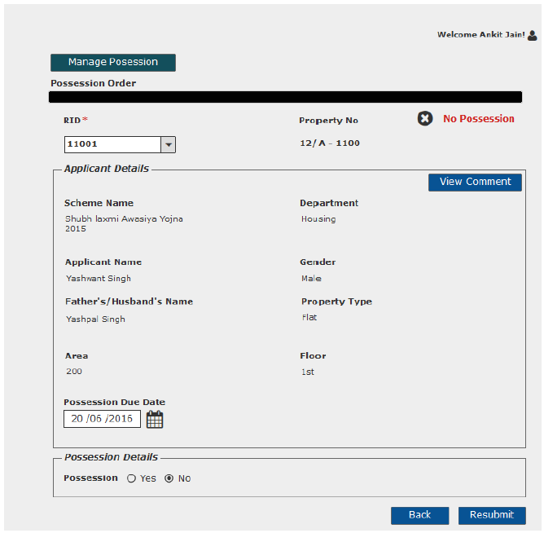
Request with No Possession
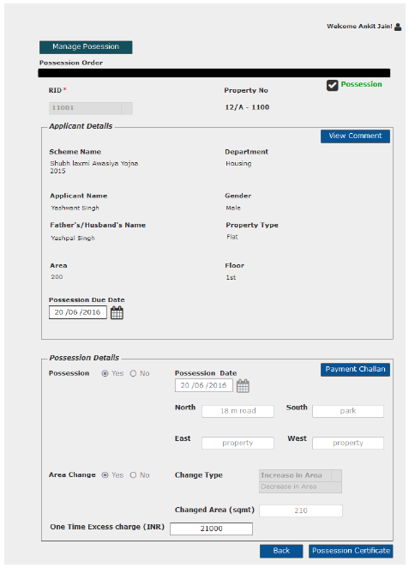
Approved Request-Increased Area
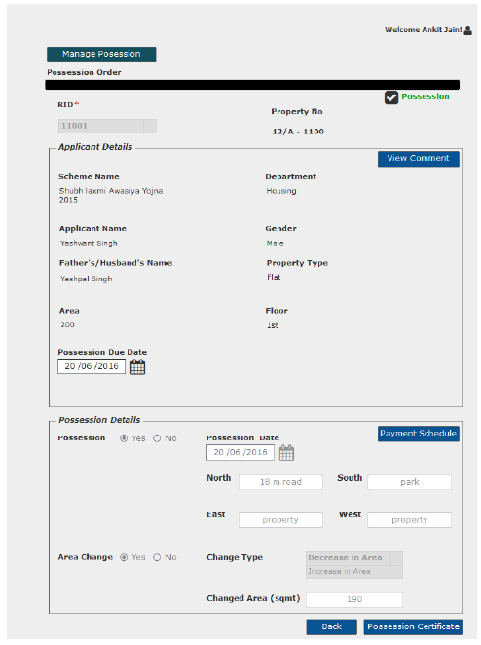
Approved request- Decreased Area

User Story- View Request- Approver

Sprint | 5
User Story ID | 004
User Story Title | View Request
Actors | Approver
Story | As an Approver, I want to view submitted possession order request of a property.
Pre Conditions | - User should have required access rights.
Business Criteria | - If the request is not actioned then, user would get ‘Submit’ button along with back button and change in area button.  - If request is cancelled then, user would get only back option.  - If possession is given then, user would get ‘Possession Certificate’ button and ‘back’ option.  - If possession is not given then, for these requests user has the option to change the status and submit again along with option to view previous comment and ‘back; button.
Acceptance Criteria | - User would click on a particular request from the grid under Manage Request menu  - User would get a screen which would display the following information:  - RID  - Property No  - Scheme Name  - Department  - Applicant Name  - Father/Husband Name  - Property type  - Area  - Floor (In case of flats)  - Possession due date.  - Possession details: In case of possession  - Possession Date: disabled ( for approved requests)  - Location: disabled ( North, South, East, West)  - Area Change: disabled (in case of change in area)  - In case of increase in area:  - Change Type: disabled label  - Changed Area: disabled label  - In case of decrease in area:  - Decrease in Area: disabled label  - Changed Area: disabled label  - Along with this information, user would get different options based on the scenario( see Business Rules)
Field level Validation

Mock-ups
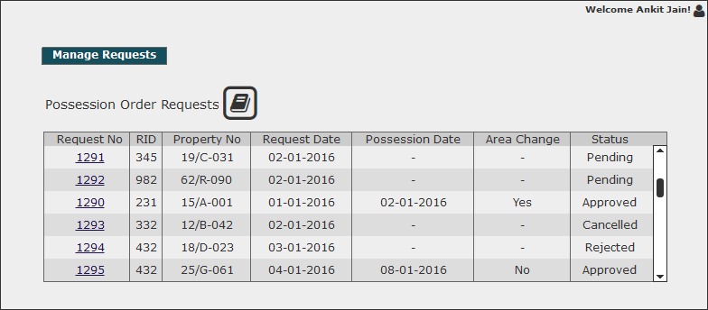

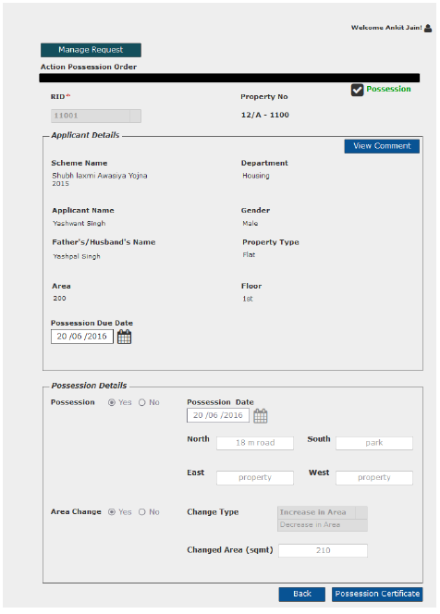
Possession order for which possession is given

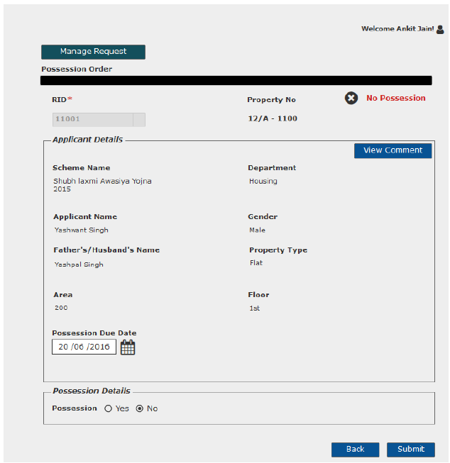
Request for which possession is not given

User Story- Resubmit request for possession order

Sprint | 5
User Story ID | 006
User Story Title | Resubmit request for possession order
Actors | Department User
Story | As a department user, I want to resubmit possession order request of a property.
Pre Conditions | - User should have required access rights.
Business Criteria | - Only Cancelled and rejected requests would be resubmitted.  - Requested date would be updated on the grid.
Acceptance Criteria | - User would click on a particular request from the grid under manage Possession menu.  - Request will be displayed and user would click on the ‘Resubmit’ button to request again.  - Alternatively, user would click on ‘Back button to return to the manage possession page without making any changes.
Field level Validation

Mock-ups

User Story- Cancel possession order request

Sprint | 5
User Story ID | 007
User Story Title | Cancel possession order request
Actors | Department User
Story | As a department user, I want to cancel possession order request of a property.
Pre Conditions | - User should have required access rights.
Business Criteria | - Only those request which has the status ‘Pending’, would be cancelled.
Acceptance Criteria | - User would click on a particular request from the grid under manage possession menu.  - Request will be displayed and user would click on the ‘Cancel Request’ button to cancel the request.  - User would get a confirmation message to cancel request. If user clicks on ‘Yes’, request would be cancelled. If user selects ‘No’ , no action takes place.  - Alternatively, user would click on ‘back’ button to return to the manage possession page without making any changes.
Field level Validation

Mock-ups
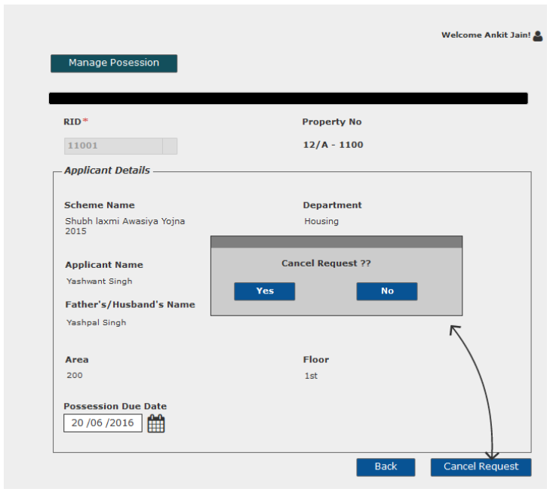

User Story- View Comment – Department user

Sprint | 5
User Story ID | 008
User Story Title | View Comment
Actors | Department user
Story | As a department user, I want to view comment on Approved/Rejected possession order request.
Pre Conditions | - User should have required access rights.
Business Criteria | - Only, approved/rejected request would contain the option to View comment.
Acceptance Criteria | - User would click on ‘View Comment’ button on possession order request screen.  - User would see a Popup window with the following information:  - Comment from  - Comment  - Comment Date  - If user needs to go back or cancel this screen, user would click on ‘Close’ button and the control will be directed to possession order request screen.

Mock-ups
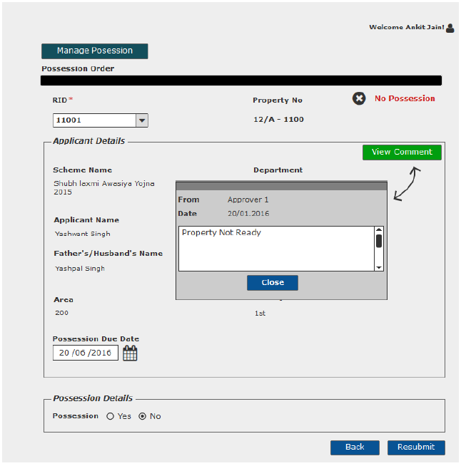
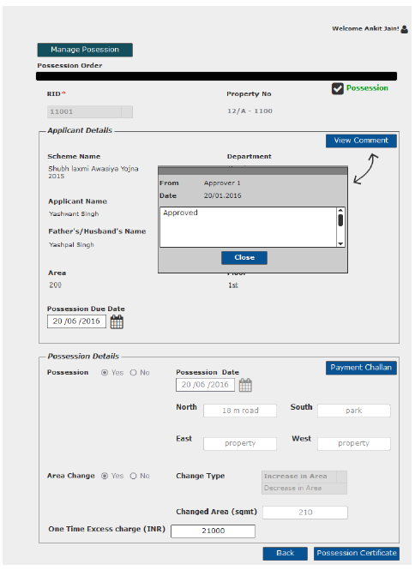

User Story- View Comment – Approver

Sprint | 4
User Story ID | 009
User Story Title | View Comment
Actors | Approver
Story | As an approver, I want to view comment on Approved/Rejected possession order request.
Pre Conditions | - User should have required access rights.
Business Criteria | - Only, approved/rejected request would contain the option to View comment.
Acceptance Criteria | - User would click on ‘View Comment’ button on possession order request screen.  - User would see a Popup window with the following information:  - Comment from  - Comment  - Comment Date  - If user needs to go back or cancel this screen, user would click on ‘Close’ button and the control will be directed to possession order request screen.

Mock-ups

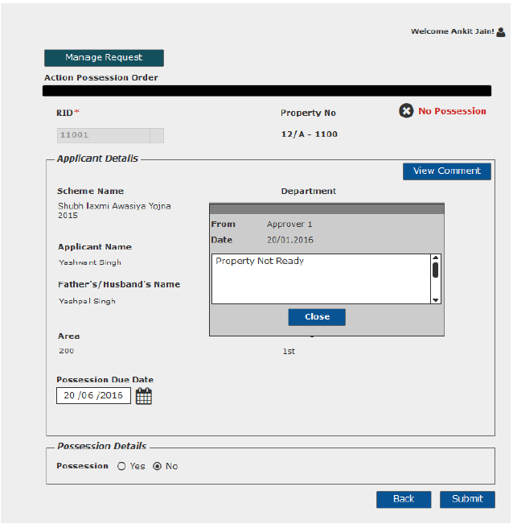

User Story- Generate Possession Certificate

Sprint | 5
User Story ID | 009
User Story Title | Generate Possession Certificate
Actors | Department user/Approver
Story | As a department user/Approver, I want to generate possession certificate.
Pre Conditions | - User should have required access rights.
Business Criteria | - Only, approved request would contain the option to generate possession certificate.  - System would check for payment of one time excess charge in case of increase in area. If not payed then, possession certificate will not be generated.
Acceptance Criteria | - User would click on ‘Possession Certificate’ button on possession order request screen.  - Possession certificate would be displayed on a separate screen.  - User would have the options to save the file to his local system by clicking on ‘Download’ button or print possession certificate by clicking on ‘Print’ button.
Field Level Validations

Mock-ups

Requestor Screen

Approver Screen

User Story- Generate Payment challan- One Time Excess Area Charge
Sprint | 5
User Story ID | 010
User Story Title | Generate Payment challan- One Time Excess Area Charge
Actors | Department user
Story | As a department user, I want to generate payment challan for one time excess area charge.
Pre Conditions | - User should have required access rights.
Business Criteria | - Only, approved request would contain the option to generate payment challan in case of increase in area.
Acceptance Criteria | - User would open the request on manage possession screen.  - User would fill the one time excess charge.  - User would click on ‘Payment challan’ button.  - Onetime payment challan would be displayed on a separate screen.  - User would have the options to save the file to his local system by clicking on ‘Download’ button or print payment challan by clicking on ‘Print’ button.
Field Level Validations | - One time excess charge: decimal (12,3).

Mock-ups

User Story- Generate Revised payment schedule

Sprint | 5
User Story ID | 011
User Story Title | Generate revised payment schedule
Actors | Department user
Story | As a department user, I want generate revised payment schedule.
Pre Conditions | - User should have required access rights.
Business Criteria | - Only, approved request would contain the option to generate revised payment schedule in case of decrease in area.
Acceptance Criteria | - User would click on ‘Revised payment Schedule’ button on possession order request screen.  - Payment schedule would be displayed on a separate screen.  - User would have the options to save the file to his local system by clicking on ‘Download’ button or print payment schedule by clicking on ‘Print’ button.
Field Level Validations

Mock-ups

User Story- SMS/Email Notifications to allottee

Sprint | 5
User Story ID | 011
User Story Title | SMS/Email notifications to allottee
Actors | Allottee
Story | As an allottee I want system to send me SMS/email notifications for possession request
Pre Conditions | - User should have required access rights.
Business Criteria | - An SMS/Email notification would be send to allottee once, the request is submitted for possession order.  - An SMS/Email notification would be send to allottee once, the request is cancelled.  - An SMS/Email notification would be send to allottee once, the request is rejected with comment.  - An SMS/Email notification would be send to allottee once, the request is approved:  No Area Change  An SMS/Email notification would be send to the customer informing him to collect his possession letter within 15 days after that penalty would be levied.  Case b: Excess Area  An SMS/email notification would be send to the customer informing him about the excess area and to pay one time excess amount within 15 days of request in order to collect his possession certificate, after that penalty would be levied.  Case c: Decreased Area  An SMS/Email notification would be send to the customer informing him about the decreased area and to collect his possession letter within 15 days after that penalty would be levied. Allottee would also be informed to collect his revised payment schedule.  - An SMS/Email notification would be send to allottee once, the possession certificate is generated to customer to have his building plan approved within a specific timeframe ( Not applicable in case of housing department)
Acceptance Criteria
Field Level Validations

